Roy Dey 914191568

Patrick Liao

PS1

**Part1**

$◻$

1. In some situations, if a filter is separable, convolution can be factored into two steps by convolving all the rows and then all the columns. Using this associative trick gives a computational complexity advantage.
2. 1 1 1 1 1 0 1 1
3. The variations in intensity of Gaussian noise is drawn from a Gaussian normal distribution. If the noise you expect to encounter does not match this kind of noise, then the result of your imaging algorithm may not produce optimal results.

Assume we have numerous images of the most common flaws (at each stage of production) the product may be subject to.

On each frame of the video do the following:

1. Use edge detection to outline the products on the conveyor belt. If more complicated techniques such as holistically-nested edge detection are out of reach, canny edge detection with hysteresis thresholding will do.
2. Use the Chamfer distance matching technique to determine if an object looks flawed. Again, this requires a large amount of template shapes to determine what a flawed product will look like.
3. If an object matches, we know it is flawed so our system will send a report.
4. Get the next frame and go back to step 1

**Part 2**

1. Reduce Width Results



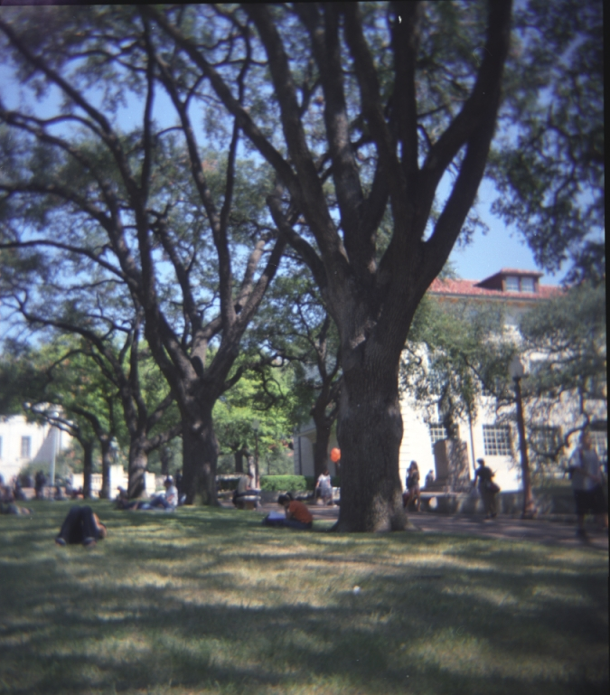

1. Reduce Height Results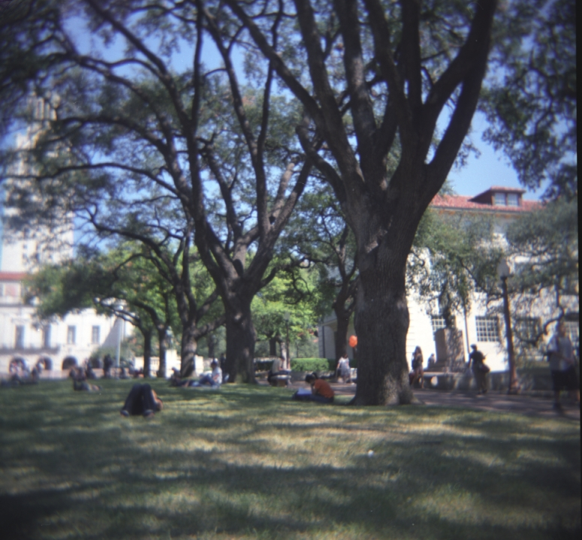
2. Energy Map

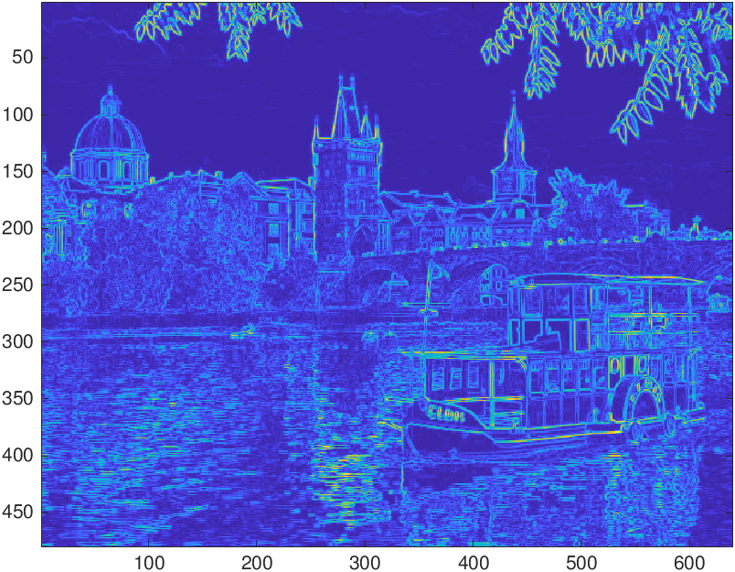

Cumulative Minimum Energy Map (Horizontal)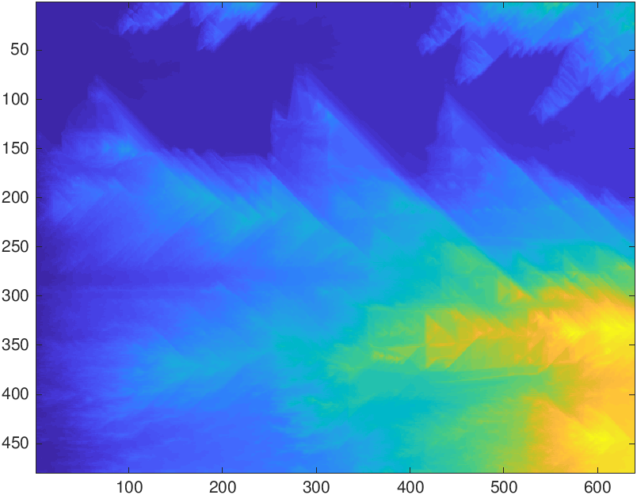

Cumulative Minimum Energy Map (Vertical)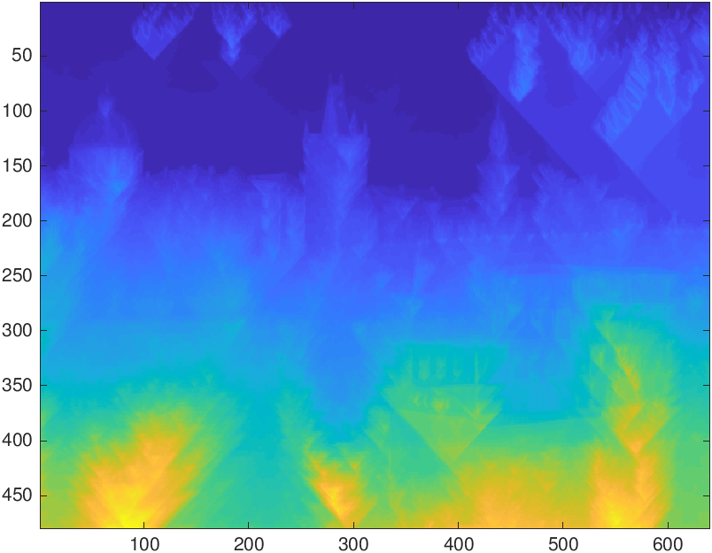

Because the energy map is produced from derivative calculations in the form of a gradient, the areas of the image which experience the highest rate of change in intensity are given higher energy values. Therefore, it makes sense that the energy map seems to outline the edges within the image, as edges are often the border between two very different colors(meaning a large change in intensity). The sky has been given a low energy score as it is relatively uniform and only offers small changes of intensity.

In the horizontal cumulative minimum energy map, the lowest values of intensity appear near the top of the image and the greatest near the bottom-right corner. The water ripples and boat (near the bottom of the image) contribute the highest intensity values. Therefore, when energy is summed from left to right, high intensity energy values are naturally concentrated near the bottom-right corner. The sky’s low energy value means that the cumulative energy calculated from left to right ends up relatively small, explaining why the top right hand of the image is relatively low energy.

In the vertical cumulative minimum energy map, the lowest values of intensity appear near the top of the image and the greatest near the bottom. Again, the sky is uniformly low in energy meaning the top of the image has low cumulative energy. The bottom of the image is high in intensity because the energy values from the buildings, bridge, water ripples, and boat are summed from top to bottom.

1. 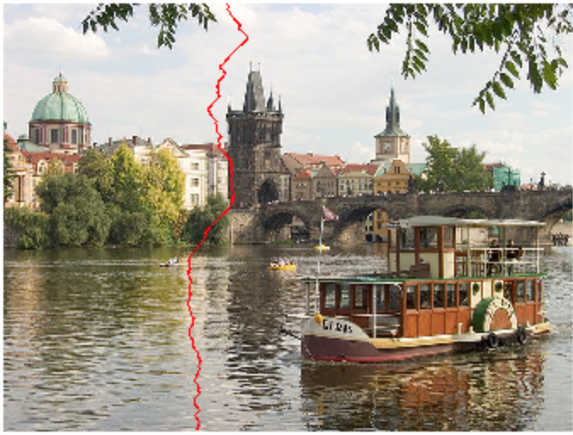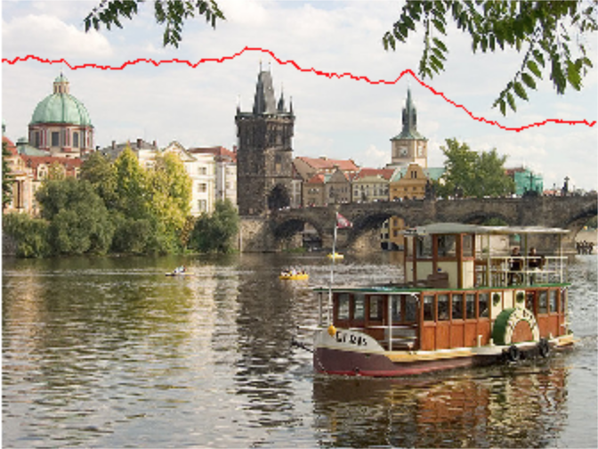

These are optimal seams for the photo as they avoid any sudden, drastic changes in energy. Since, changes in energy are measured via the gradient function, the minimum cumulative energy map that the find_seam() function refers to will contain a seam that avoid colliding with any objects or color changes that is visible in the image.

1. 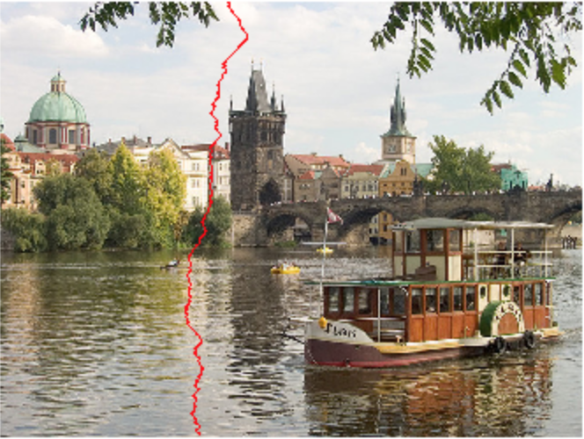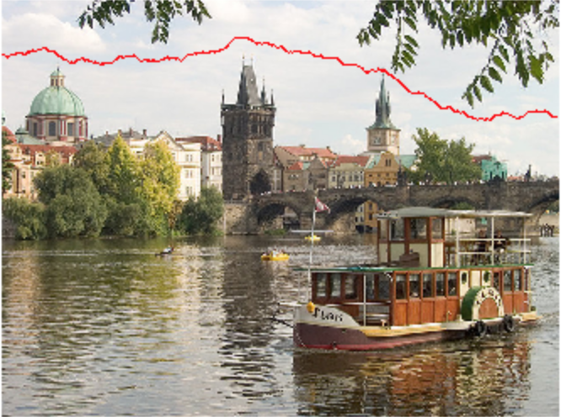

The parameter that was changed is the gradient filter. In this case, we tried using the roberts filter. The Roberts filter finds the gradient between diagonally adjacent pixels, in contrast to vertically adjacent for prewitt. The horizontal seam isn’t changed much for the two pictures, as the seam that outlines the sky for the image has the lowest energy change regardless of the gradient filter. For the The vertical seam deviates to the left compared to Prewitt, most likely because the black and white contrast from the black tower and white building would cause high energy deviation in the context of the Roberts filter.

1. For the modified images, we noticed the first seams that were found, both vertical and horizontal, fit. However, the images did not look right after decreasing width by a large number of pixels. Portions of the image that are significant to the image seemed to be directly cut off. We believe that although our find_seam functions work as expected, judging from the first seam shown in view_seam(), as the image continues to shrink the cumulative minimum energy map calculated bad values for the image. As a result, the resulting images shown in the output are inconsistent with our expectations.